**Task1**

**Screenshot: the given screenshot represent the whole data exported from hdfs**

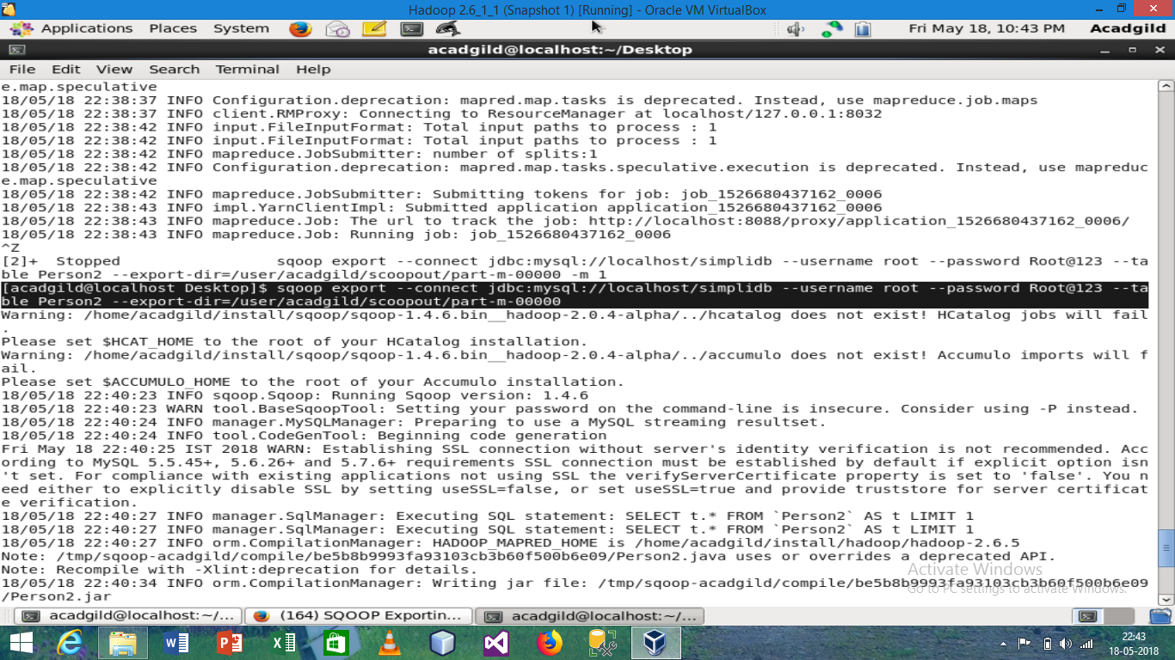

**Task2**

**Screenshot:**

**The shaded region is the command of exporting the data from hdfs where person_id=2**

